PROJECT
USED CAR PRICE ANALYSIS

Introduction
The market for used cars is a significant segment of the automotive industry, with millions of used cars sold each year around the world. This market includes a variety of vehicles, ranging from economy cars to luxury vehicles, and is driven by a wide range of consumer preferences and needs. The global used car market size was valued at
$1.41 trillion in 2020 and is projected to reach $2.48 trillion by 2028, growing at a CAGR of 7.9% during the forecast period.

Research on the factors influencing used car prices can provide valuable insights into the market dynamics affecting supply and demand. A stable and efficient used car market can provide affordable transportation options for consumers, promote competition and innovation among businesses, and contribute to the economy’s overall
health. Understanding the relationship between supply and demand in the used car market is also important. Factors such as the availability of financing, the level of competition among dealerships, and the age and condition of the vehicles can all impact the prices that consumers are willing to pay for used cars. By studying these and
other factors, policymakers and businesses can develop strategies to promote a healthy and efficient used car market.

Used car price analysis involves examining the factors that influence the pricing of pre-owned vehicles in the market. This process helps identify trends, patterns, and key variables such as the car’s make, model, year, mileage, condition, and location. By analyzing this data, consumers can make informed decisions when buying or selling a used car, while businesses, such as dealerships and online marketplaces, can optimize pricing strategies to stay competitive. Factors like market demand, seasonal variations, and economic conditions also play significant roles in used car pricing.

In recent years, the demand for used cars has surged due to various reasons, including the affordability compared to new cars, and economic uncertainty. The advent of online platforms that list and aggregate used car inventories has further driven the need for price analysis. Machine learning models and data-driven tools are often employed to predict future price trends, identify undervalued or overvalued vehicles, and provide fair market value estimates. Analyzing historical sales data alongside current listings helps in understanding the dynamics of depreciation, consumer preferences, and the impact of external factors such as fuel prices or supply chain disruptions.

WEB SCRAPPING:
Web scraping is the process of programmatically extracting data from websites. It enables users to gather large amounts of structured or semi-structured data from the web, often for purposes such as research, business intelligence, or machine learning. The core concept involves retrieving the HTML of a web page, parsing it to find the relevant data, and then storing that data in a structured format, such as a CSV file or database. The growth of data on the internet has made web scraping an essential tool for various industries, as manually collecting and analyzing this data would be too time-consuming.

One of the most common methods of web scraping involves using Python libraries such as BeautifulSoup or Scrapy. BeautifulSoup allows developers to parse HTML and XML documents, navigating the document tree and searching for specific elements like tables, lists, or divs containing the target data. Scrapy, on the other hand, is a more robust framework that can handle large-scale scraping, manage requests, and even work with APIs. For websites that load data dynamically through JavaScript, tools like Selenium and Puppeteer are useful because they can simulate a web browser, interacting with pages to trigger the loading of the necessary data.

While web scraping is powerful, it also presents some legal and ethical challenges. Many websites have policies that restrict scraping, often outlined in their terms of service. Additionally, the robots.txt file on a website specifies which parts of the site can and cannot be scraped. Ignoring these guidelines may lead to legal issues or getting blocked by the site. Furthermore, excessive scraping can put a strain on a website’s server, disrupting the experience for other users. This is why ethical scrapers implement features like rate limiting, ensuring their requests do not overload the server.

In some cases, websites offer APIs as an alternative to web scraping, providing structured data that is easier to work with and less prone to legal issues. APIs allow users to request data directly from the server in a controlled and optimized way. However, APIs often have restrictions, such as limited access to specific data points or usage quotas. When APIs are not available or do not provide the required data, web scraping remains a valuable method for acquiring the needed information from public websites.

DATA FLOWCHART:

CODE:
import requests
from bs4 import BeautifulSoup

web=requests.get("https://www.cars24.com/buy-used-car?sort=bestmatch&serveWarrantyCount=true&listingSource=Homepage_Filters&storeCityId=3686")

web.status_code
web.content
soup=BeautifulSoup(web.content,"html.parser")
soup
results=soup.find_all('div',{'class':"_7jb8Q _1Ey60"})
len(results)
results[0].get_text()
results[1].get_text()
results[1].find('h3',{'class':'_2Out2'}).get_text()
results[1].find('h3').get_text()
results[1].find('div',{'class':'_1Oul-'}).get_text()
results[1].find('div',{'class':'_1Oul- VMjdr'}).get_text()
results[1].find('ul',{'class':'_3jRcd'}).get_text()
results[1].find('p',{'class':'_2rxhF'}).get_text()
name=[]
emi=[]
price=[]
mileage=[]
location=[]
for dell in results:
try:
name.append(dell.find('h3').get_text())
except:
name.append('n/a')
try:
emi.append(dell.find('div',{'class':'_1Oul-'}).get_text())
except:
emi.append('n/a')
try:
price.append(dell.find('div',{'class':'_1Oul- VMjdr'}).get_text())
except:
price.append('n/a')
try:
mileage.append(dell.find('ul',{'class':'_3jRcd'}).get_text())
except:
mileage.append('n/a')
try:
location.append(dell.find('p',{'class':'_2rxhF'}).get_text())
except:
location.append('n/a')
len(name)
import pandas as pd
car_dealer=pd.DataFrame({'Name':name, 'EMI':emi, 'Price':price, 'Registered------Mileage-----Fuel-----owner ':mileage,'Address':location})
car_dealer
car_dealer['Address']=car_dealer['Address'].apply(lambda x:x.strip('Free Test Drive Today at' ))
car_dealer
car_dealer.to_csv('first_page_car_details.csv',index=False)
import requests
from bs4 import BeautifulSoup

web=requests.get("https://www.cars24.com/buy-used-tata-tiago-cars-hyderabad/"
)

web.status_code
web.content
soup=BeautifulSoup(web.content,"html.parser")
soup
results=soup.find_all('div',{'class':"_7jb8Q _1Ey60"})
len(results)
results[0].get_text()
results[1].get_text()
results[1].find('h3',{'class':'_2Out2'}).get_text()
results[1].find('h3').get_text()
results[1].find('div',{'class':'_1Oul-'}).get_text()
results[1].find('div',{'class':'_1Oul- VMjdr'}).get_text()
results[1].find('ul',{'class':'_3jRcd'}).get_text()
results[1].find('p',{'class':'_2rxhF'}).get_text()
name=[]
emi=[]
price=[]
mileage=[]
location=[]
for dell in results:
try:
name.append(dell.find('h3').get_text())
except:
name.append('n/a')
try:
emi.append(dell.find('div',{'class':'_1Oul-'}).get_text())
except:
emi.append('n/a')
try:
price.append(dell.find('div',{'class':'_1Oul- VMjdr'}).get_text())
except:
price.append('n/a')
try:
mileage.append(dell.find('ul',{'class':'_3jRcd'}).get_text())
except:
mileage.append('n/a')
try:
location.append(dell.find('p',{'class':'_2rxhF'}).get_text())
except:
location.append('n/a')
len(name)
import pandas as pd
car_dealer=pd.DataFrame({'Name':name, 'EMI':emi, 'Price':price, 'Registered------Mileage-----Fuel-----owner ':mileage,'Address':location})
car_dealer
car_dealer['Address']=car_dealer['Address'].apply(lambda x:x.strip('Free Test Drive Today at' ))
car_dealer
car_dealer.to_csv('second_page_car_details.csv',index=False)

import requests
from bs4 import BeautifulSoup

web=requests.get("https://www.cars24.com/buy-used-hyundai-i20-cars-mumbai/
")

web.status_code
web.content
soup=BeautifulSoup(web.content,"html.parser")
soup
results=soup.find_all('div',{'class':"_7jb8Q _1Ey60"})
len(results)
results[0].get_text()
results[1].get_text()
results[1].find('h3',{'class':'_2Out2'}).get_text()
results[1].find('h3').get_text()
results[1].find('div',{'class':'_1Oul-'}).get_text()
results[1].find('div',{'class':'_1Oul- VMjdr'}).get_text()
results[1].find('ul',{'class':'_3jRcd'}).get_text()
results[1].find('p',{'class':'_2rxhF'}).get_text()
name=[]
emi=[]
price=[]
mileage=[]
location=[]
for dell in results:
try:
name.append(dell.find('h3').get_text())
except:
name.append('n/a')
try:
emi.append(dell.find('div',{'class':'_1Oul-'}).get_text())
except:
emi.append('n/a')
try:
price.append(dell.find('div',{'class':'_1Oul- VMjdr'}).get_text())
except:
price.append('n/a')
try:
mileage.append(dell.find('ul',{'class':'_3jRcd'}).get_text())
except:
mileage.append('n/a')
try:
location.append(dell.find('p',{'class':'_2rxhF'}).get_text())
except:
location.append('n/a')
len(name)
import pandas as pd
car_dealer=pd.DataFrame({'Name':name, 'EMI':emi, 'Price':price, 'Registered------Mileage-----Fuel-----owner ':mileage,'Address':location})
car_dealer
car_dealer['Address']=car_dealer['Address'].apply(lambda x:x.strip('Free Test Drive Today at' ))
car_dealer
car_dealer.to_csv('first_page_car_details.csv',index=False)
import requests
from bs4 import BeautifulSoup

web=requests.get("https://www.cars24.com/buy-used-car?sort=bestmatch&serveWarrantyCount=true&listingSource=Homepage_Filters&storeCityId=3686")

web.status_code
web.content
soup=BeautifulSoup(web.content,"html.parser")
soup
results=soup.find_all('div',{'class':"_7jb8Q _1Ey60"})
len(results)
results[0].get_text()
results[1].get_text()
results[1].find('h3',{'class':'_2Out2'}).get_text()
results[1].find('h3').get_text()
results[1].find('div',{'class':'_1Oul-'}).get_text()
results[1].find('div',{'class':'_1Oul- VMjdr'}).get_text()
results[1].find('ul',{'class':'_3jRcd'}).get_text()
results[1].find('p',{'class':'_2rxhF'}).get_text()
name=[]
emi=[]
price=[]
mileage=[]
location=[]
for dell in results:
try:
name.append(dell.find('h3').get_text())
except:
name.append('n/a')
try:
emi.append(dell.find('div',{'class':'_1Oul-'}).get_text())
except:
emi.append('n/a')
try:
price.append(dell.find('div',{'class':'_1Oul- VMjdr'}).get_text())
except:
price.append('n/a')
try:
mileage.append(dell.find('ul',{'class':'_3jRcd'}).get_text())
except:
mileage.append('n/a')
try:
location.append(dell.find('p',{'class':'_2rxhF'}).get_text())
except:
location.append('n/a')
len(name)
import pandas as pd
car_dealer=pd.DataFrame({'Name':name, 'EMI':emi, 'Price':price, 'Registered------Mileage-----Fuel-----owner ':mileage,'Address':location})
car_dealer
car_dealer['Address']=car_dealer['Address'].apply(lambda x:x.strip('Free Test Drive Today at' ))
car_dealer
car_dealer.to_csv('first_page_car_details.csv',index=False)

import requests
from bs4 import BeautifulSoup

web=requests.get("https://www.cars24.com/buy-used-car?sort=bestmatch&serveWarrantyCount=true&listingSource=Homepage_Filters&storeCityId=3686")

web.status_code
web.content
soup=BeautifulSoup(web.content,"html.parser")
soup
results=soup.find_all('div',{'class':"_7jb8Q _1Ey60"})
len(results)
results[0].get_text()
results[1].get_text()
results[1].find('h3',{'class':'_2Out2'}).get_text()
results[1].find('h3').get_text()
results[1].find('div',{'class':'_1Oul-'}).get_text()
results[1].find('div',{'class':'_1Oul- VMjdr'}).get_text()
results[1].find('ul',{'class':'_3jRcd'}).get_text()
results[1].find('p',{'class':'_2rxhF'}).get_text()
name=[]
emi=[]
price=[]
mileage=[]
location=[]
for dell in results:
try:
name.append(dell.find('h3').get_text())
except:
name.append('n/a')
try:
emi.append(dell.find('div',{'class':'_1Oul-'}).get_text())
except:
emi.append('n/a')
try:
price.append(dell.find('div',{'class':'_1Oul- VMjdr'}).get_text())
except:
price.append('n/a')
try:
mileage.append(dell.find('ul',{'class':'_3jRcd'}).get_text())
except:
mileage.append('n/a')
try:
location.append(dell.find('p',{'class':'_2rxhF'}).get_text())
except:
location.append('n/a')
len(name)
import pandas as pd
car_dealer=pd.DataFrame({'Name':name, 'EMI':emi, 'Price':price, 'Registered------Mileage-----Fuel-----owner ':mileage,'Address':location})
car_dealer
car_dealer['Address']=car_dealer['Address'].apply(lambda x:x.strip('Free Test Drive Today at' ))
car_dealer
car_dealer.to_csv('first_page_car_details.csv',index=False)
import requests
from bs4 import BeautifulSoup

web=requests.get("https://www.cars24.com/buy-used-car?sort=bestmatch&serveWarrantyCount=true&listingSource=Homepage_Filters&storeCityId=3686")

web.status_code
web.content
soup=BeautifulSoup(web.content,"html.parser")
soup
results=soup.find_all('div',{'class':"_7jb8Q _1Ey60"})
len(results)
results[0].get_text()
results[1].get_text()
results[1].find('h3',{'class':'_2Out2'}).get_text()
results[1].find('h3').get_text()
results[1].find('div',{'class':'_1Oul-'}).get_text()
results[1].find('div',{'class':'_1Oul- VMjdr'}).get_text()
results[1].find('ul',{'class':'_3jRcd'}).get_text()
results[1].find('p',{'class':'_2rxhF'}).get_text()
name=[]
emi=[]
price=[]
mileage=[]
location=[]
for dell in results:
try:
name.append(dell.find('h3').get_text())
except:
name.append('n/a')
try:
emi.append(dell.find('div',{'class':'_1Oul-'}).get_text())
except:
emi.append('n/a')
try:
price.append(dell.find('div',{'class':'_1Oul- VMjdr'}).get_text())
except:
price.append('n/a')
try:
mileage.append(dell.find('ul',{'class':'_3jRcd'}).get_text())
except:
mileage.append('n/a')
try:
location.append(dell.find('p',{'class':'_2rxhF'}).get_text())
except:
location.append('n/a')
len(name)
import pandas as pd
car_dealer=pd.DataFrame({'Name':name, 'EMI':emi, 'Price':price, 'Registered------Mileage-----Fuel-----owner ':mileage,'Address':location})
car_dealer
car_dealer['Address']=car_dealer['Address'].apply(lambda x:x.strip('Free Test Drive Today at' ))
car_dealer
car_dealer.to_csv('first_page_car_details.csv',index=False)
import requests
from bs4 import BeautifulSoup

web=requests.get("https://www.cars24.com/buy-used-car?sort=bestmatch&serveWarrantyCount=true&listingSource=Homepage_Filters&storeCityId=3686")

web.status_code
web.content
soup=BeautifulSoup(web.content,"html.parser")
soup
results=soup.find_all('div',{'class':"_7jb8Q _1Ey60"})
len(results)
results[0].get_text()
results[1].get_text()
results[1].find('h3',{'class':'_2Out2'}).get_text()
results[1].find('h3').get_text()
results[1].find('div',{'class':'_1Oul-'}).get_text()
results[1].find('div',{'class':'_1Oul- VMjdr'}).get_text()
results[1].find('ul',{'class':'_3jRcd'}).get_text()
results[1].find('p',{'class':'_2rxhF'}).get_text()
name=[]
emi=[]
price=[]
mileage=[]
location=[]
for dell in results:
try:
name.append(dell.find('h3').get_text())
except:
name.append('n/a')
try:
emi.append(dell.find('div',{'class':'_1Oul-'}).get_text())
except:
emi.append('n/a')
try:
price.append(dell.find('div',{'class':'_1Oul- VMjdr'}).get_text())
except:
price.append('n/a')
try:
mileage.append(dell.find('ul',{'class':'_3jRcd'}).get_text())
except:
mileage.append('n/a')
try:
location.append(dell.find('p',{'class':'_2rxhF'}).get_text())
except:
location.append('n/a')
len(name)
import pandas as pd
car_dealer=pd.DataFrame({'Name':name, 'EMI':emi, 'Price':price, 'Registered------Mileage-----Fuel-----owner ':mileage,'Address':location})
car_dealer
car_dealer['Address']=car_dealer['Address'].apply(lambda x:x.strip('Free Test Drive Today at' ))
car_dealer
car_dealer.to_csv('first_page_car_details.csv',index=False)
import requests
from bs4 import BeautifulSoup

web=requests.get("https://www.cars24.com/buy-used-car?sort=bestmatch&serveWarrantyCount=true&listingSource=Homepage_Filters&storeCityId=3686")

web.status_code
web.content
soup=BeautifulSoup(web.content,"html.parser")
soup
results=soup.find_all('div',{'class':"_7jb8Q _1Ey60"})
len(results)
results[0].get_text()
results[1].get_text()
results[1].find('h3',{'class':'_2Out2'}).get_text()
results[1].find('h3').get_text()
results[1].find('div',{'class':'_1Oul-'}).get_text()
results[1].find('div',{'class':'_1Oul- VMjdr'}).get_text()
results[1].find('ul',{'class':'_3jRcd'}).get_text()
results[1].find('p',{'class':'_2rxhF'}).get_text()
name=[]
emi=[]
price=[]
mileage=[]
location=[]
for dell in results:
try:
name.append(dell.find('h3').get_text())
except:
name.append('n/a')
try:
emi.append(dell.find('div',{'class':'_1Oul-'}).get_text())
except:
emi.append('n/a')
try:
price.append(dell.find('div',{'class':'_1Oul- VMjdr'}).get_text())
except:
price.append('n/a')
try:
mileage.append(dell.find('ul',{'class':'_3jRcd'}).get_text())
except:
mileage.append('n/a')
try:
location.append(dell.find('p',{'class':'_2rxhF'}).get_text())
except:
location.append('n/a')
len(name)
import pandas as pd
car_dealer=pd.DataFrame({'Name':name, 'EMI':emi, 'Price':price, 'Registered------Mileage-----Fuel-----owner ':mileage,'Address':location})
car_dealer
car_dealer['Address']=car_dealer['Address'].apply(lambda x:x.strip('Free Test Drive Today at' ))
car_dealer
car_dealer.to_csv('first_page_car_details.csv',index=False)
import requests
from bs4 import BeautifulSoup

web=requests.get("https://www.cars24.com/buy-used-car?sort=bestmatch&serveWarrantyCount=true&listingSource=Homepage_Filters&storeCityId=3686")

web.status_code
web.content
soup=BeautifulSoup(web.content,"html.parser")
soup
results=soup.find_all('div',{'class':"_7jb8Q _1Ey60"})
len(results)
results[0].get_text()
results[1].get_text()
results[1].find('h3',{'class':'_2Out2'}).get_text()
results[1].find('h3').get_text()
results[1].find('div',{'class':'_1Oul-'}).get_text()
results[1].find('div',{'class':'_1Oul- VMjdr'}).get_text()
results[1].find('ul',{'class':'_3jRcd'}).get_text()
results[1].find('p',{'class':'_2rxhF'}).get_text()
name=[]
emi=[]
price=[]
mileage=[]
location=[]
for dell in results:
try:
name.append(dell.find('h3').get_text())
except:
name.append('n/a')
try:
emi.append(dell.find('div',{'class':'_1Oul-'}).get_text())
except:
emi.append('n/a')
try:
price.append(dell.find('div',{'class':'_1Oul- VMjdr'}).get_text())
except:
price.append('n/a')
try:
mileage.append(dell.find('ul',{'class':'_3jRcd'}).get_text())
except:
mileage.append('n/a')
try:
location.append(dell.find('p',{'class':'_2rxhF'}).get_text())
except:
location.append('n/a')
len(name)
import pandas as pd
car_dealer=pd.DataFrame({'Name':name, 'EMI':emi, 'Price':price, 'Registered------Mileage-----Fuel-----owner ':mileage,'Address':location})
car_dealer
car_dealer['Address']=car_dealer['Address'].apply(lambda x:x.strip('Free Test Drive Today at' ))
car_dealer
car_dealer.to_csv('first_page_car_details.csv',index=False)

Extract, Transform, and Load (ETL)
- Extraction
The Extract step in ETL refers to retrieving data from various source systems. These sources can range from structured databases, like SQL or Oracle, to unstructured sources such as web logs or social media platforms. The main objective of this phase is to ensure that the data is collected in its raw form, without altering or filtering it, to capture the full scope of information. Efficient extraction is critical for ensuring data availability for the subsequent transformation steps. This phase can involve querying multiple databases or API calls, and in modern systems, it may even include real-time data streaming.
- Transformation
After the data is extracted, the next step is Transform, where the raw data is processed and prepared for analysis. This stage includes cleaning the data (removing duplicates, handling missing values), standardizing formats (e.g., dates, currencies), and performing more complex operations such as joining tables, aggregating metrics, or enriching the data with external sources. Data transformation is critical because it ensures the data is structured and ready for analysis or reporting. The goal is to convert raw, unstructured data into a usable format, often involving business logic, filtering irrelevant information, or categorizing datasets for meaningful insights.
- Loading
The final step is Load, which involves transferring the transformed data into a target system, usually a data warehouse, a data lake, or any system designed for querying and reporting. The loading process can be scheduled in batches (for large datasets) or in real-time (for dynamic systems that require immediate data availability). The integrity and accuracy of the transformed data are paramount in this phase, as any discrepancies can lead to faulty analysis or decision-making. Modern ETL processes also incorporate monitoring and logging mechanisms to ensure that the data is loaded correctly and efficiently.
- Importance of ETL in Modern Data Architecture
ETL is essential for modern data-driven organizations because it allows them to consolidate data from multiple, disparate sources and make it available in a unified form. Businesses rely on accurate, clean, and timely data to make informed decisions, and ETL processes ensure that this data is reliable and actionable. With the increasing volume of data and complexity in data ecosystems, ETL tools and methodologies are evolving to handle larger datasets, support real-time processing, and adapt to cloud architectures. ETL systems are also crucial for ensuring data quality, governance, and compliance, making them a cornerstone of business intelligence and data management strategies.
The ETL process in Power BI involves three primary steps: Extract, Transform, and Load. Power BI uses the Power Query Editor to handle these steps, enabling users to prepare data for reporting and analysis. Here's how the process works:

1. Extract (Data Extraction)
- Connect to Data Sources: In Power BI, you can connect to a wide range of data sources like SQL databases, Excel files, cloud platforms (Azure, Salesforce), APIs, web data, and more.
- Choose Data for Extraction: Once connected, select the specific tables, sheets, or data elements you need for your analysis.
- Preview Data: Power BI allows you to preview the data before extracting it to verify that the correct data is being selected.
Steps:
- Open Power BI Desktop.
- Click on Home > Get Data.
- Select the source and connect.
- Choose and load the data you want to work with.

2. Transform (Data Transformation)
- Clean and Prepare Data: Power BI’s Power Query Editor allows you to clean and transform the data to ensure it's in the right format. You can:
  - Remove duplicates or null values.
  - Filter data to focus on relevant records.
  - Change data types (e.g., converting text to date or numbers).
  - Split columns, merge tables, and remove unnecessary columns.
- Apply Business Logic: Transform the data by creating new calculated columns, aggregating data, or applying custom logic.
- Data Structuring: You can pivot/unpivot columns, group data, and create relationships between tables to prepare a structured dataset.
Steps:
- Click Transform Data to open Power Query Editor.
- Use transformation tools to modify and clean the dataset.
- Apply changes by clicking Close & Apply when done.

3. Load (Data Loading)
- Load Transformed Data: Once the data is clean and transformed, load it into Power BI’s data model for further analysis and visualization.
- Data Refresh Options: You can set up automatic data refresh schedules (daily, weekly, etc.) to ensure the data remains up-to-date in reports and dashboards.
- Create Data Model: After loading, you can define relationships between tables, create measures using DAX (Data Analysis Expressions), and prepare the data for visualization.
Steps:
- After transformation, click Close & Apply in Power Query Editor.
- Power BI loads the transformed data into the data model for reporting.
- You can refresh the data manually or schedule automatic refreshes to keep the data updated.

Summary of the ETL Process in Power BI:
- Extract: Connect to data sources and pull in raw data.
- Transform: Clean, reshape, and prepare the data using Power Query.
- Load: Load the transformed data into Power BI’s data model for further analysis and visualization.
This ETL process ensures that the data used in Power BI reports is clean, accurate, and ready for business insights.

Data Visualization in Power BI
Data visualization is a crucial aspect of data analysis, and Power BI excels in transforming raw data into meaningful insights through visually compelling representations. Power BI offers a wide array of visualization options, including bar charts, line graphs, pie charts, scatter plots, and geographical maps, among others. Users can easily drag and drop data fields into the canvas to create interactive reports and dashboards that not only present data but also facilitate a deeper understanding of trends, patterns, and outliers. The ability to customize visual elements, such as colors, labels, and titles, enhances the storytelling aspect of data, making it easier for stakeholders to interpret complex information.
Moreover, Power BI’s interactivity features significantly enrich the user experience. Through tooltips, filters, and slicers, users can drill down into specific data points or aggregate data at various levels, providing a dynamic way to explore data. The integration of DAX (Data Analysis Expressions) allows for advanced calculations and aggregations, further enhancing the depth of analysis. By combining these features, Power BI empowers organizations to make data-driven decisions with confidence. The seamless sharing capabilities also enable collaboration across teams, ensuring that everyone has access to the same insights and can contribute to data-informed strategies. Overall, data visualization in Power BI not only simplifies data comprehension but also fosters a culture of analytics within organizations.

Visuals:

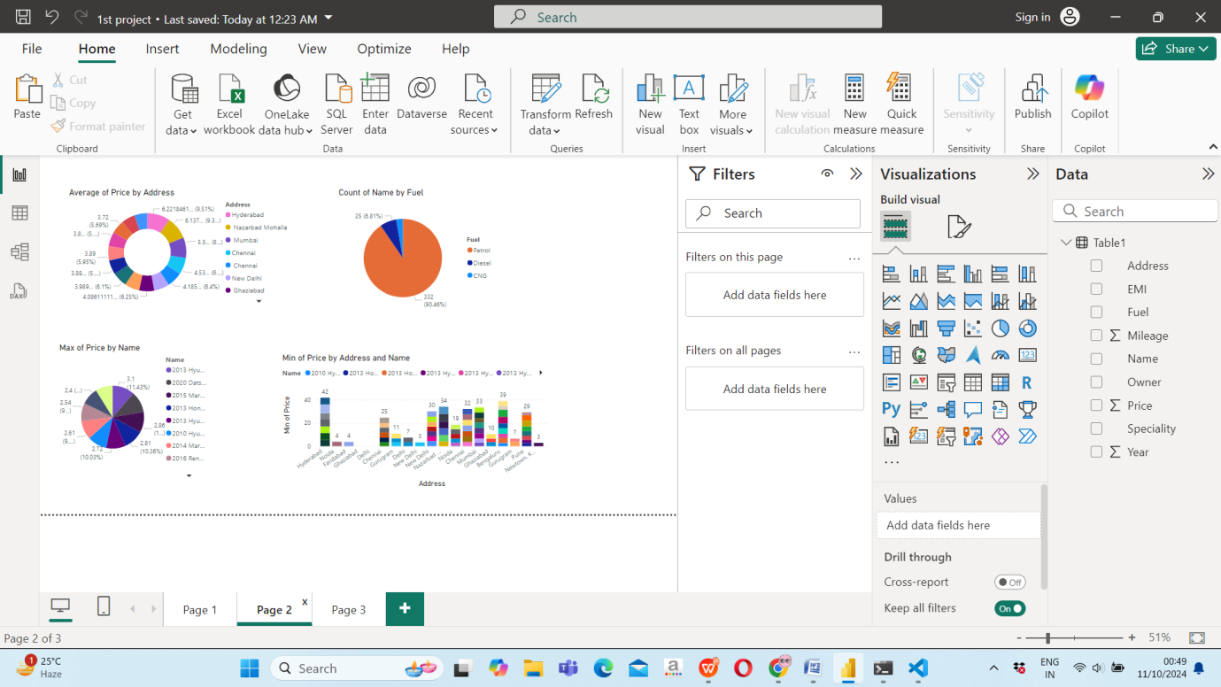
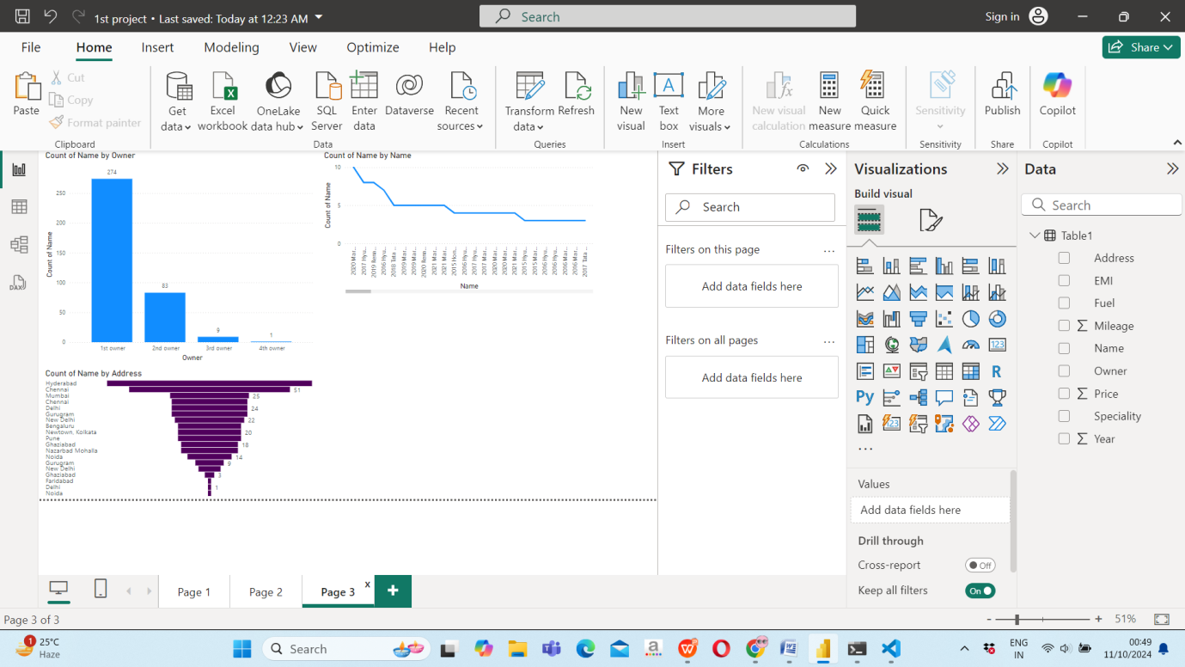
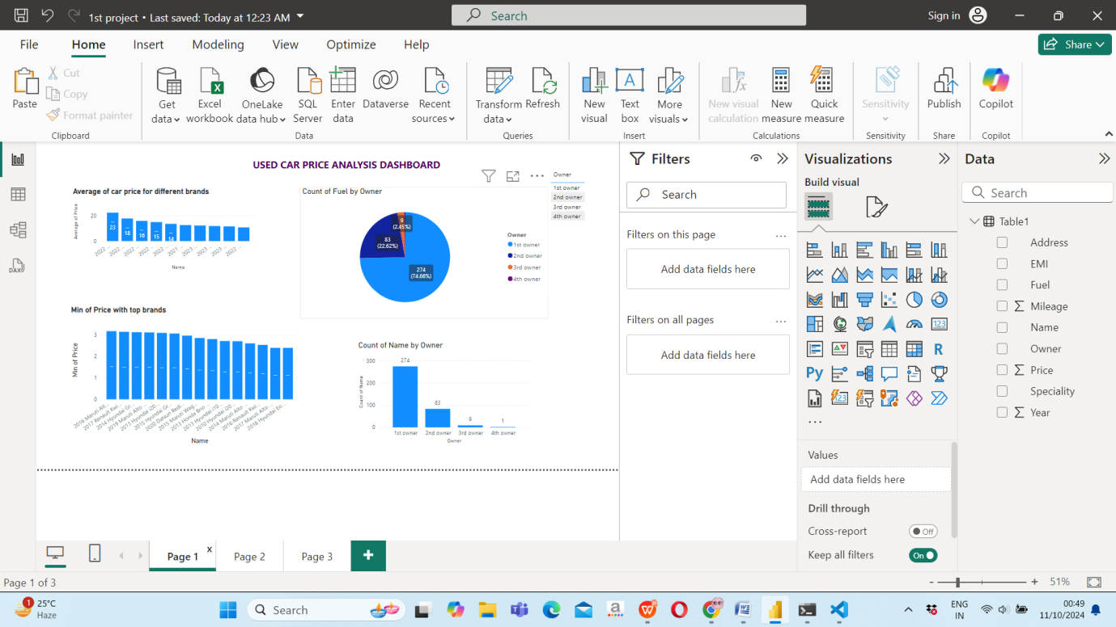

Conclusion:
The analysis of used car prices based on various car brands reveals significant insights into market trends and consumer preferences. By evaluating factors such as price, quality, and brand reputation, it becomes evident that certain brands consistently offer high-quality vehicles at more affordable price points. This analysis highlights the best options for budget-conscious buyers seeking reliable transportation without compromising on quality. Brands known for their durability and dependability, combined with competitive pricing, stand out as the best choices in the used car market.
Moreover, the data underscores the importance of thorough research and comparison when purchasing a used vehicle. Buyers can benefit from understanding the nuances of price variations among different brands and models, allowing them to make informed decisions that align with their needs and financial constraints. Ultimately, this analysis serves as a valuable resource for potential buyers, guiding them toward optimal choices that balance quality and cost, and helping them navigate the complexities of the used car market effectively.

